EEE211 The Design of an Operational Amplifier using PSpice

PART 2

Introduction:

The second part of this assignment requires you to complete the design of the operational amplifier circuit that was commenced in Part 1 to meet the following specification:

Specification:
- Differential input impedance greater than 100kΩ
- Voltage gain greater than 500,000
- Output impedance less than 1kΩ
- Output voltage to be zero volts for zero input
- Frequency response down to D.C.
- Split supply voltage +9 to -9 volts
- Total current consumption less than 5mA

In Part 1, a voltage amplifier was designed that provides a substantial part of the overall voltage gain of your op-amp and should also meet the output resistance requirement. The remaining task is to add a differential pre-amplifier stage to convert the single input amplifier to a differential input amplifier and to provide some extra voltage gain so that the overall circuit will meet the specification.

The assignment is intended to reinforce lecture material in module EEE211 and reference to the relevant lecture notes is essential.

Three basic ‘building block’ circuits were investigated in Part 1.

A common emitter amplifier
A current mirror circuit
A common collector circuit (emitter follower)

You should use this information and the Q2N2222 npn transistor and Q2N2907 pnp transistor characteristics that you obtained in Part 1 to design the differential input stage. You may need to revise the design in Part 1 slightly to achieve the overall specification.

2.1 The differential input stage

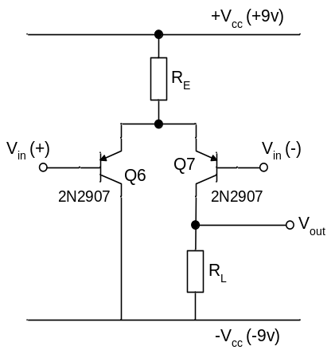

Fig. 2.1 – A pnp long tailed pair.
The basic circuit for the differential input stage to be designed is shown in fig. 2.1. It is sometimes known as a ‘long-tailed pair’ because the emitters of two transistors are connected together and taken to the appropriate supply rail via a large value resistor R_{E} (the ‘tail’). This resistor is intended to approximate a constant current source, but as seen in Part 1, the current mirror is a better alternative that will be used to replace R in this circuit.

The differential input impedance of the long-tailed pair circuit is given approximately by:-

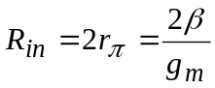 Eqn. 1

and the voltage gain by:-

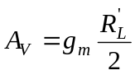 Eqn 2

Where R_{L}’ = the total effective load ‘seen’ by the collector of Q7. This will be R_{L} in parallel with r_{o} of Q7 in parallel with the input impedance of any further stage that may be connected to the V_{out} terminal.

Note that the output is taken from across R_{L}. It therefore converts two differentially-applied input voltages to a single output voltage to be supplied to the next stage.

In Part 1 you will have seen that the voltage gain of an amplifier can be improved if the load resistor is replaced by the high impedance of a current mirror circuit. This principle can be used to still greater advantage in the differential amplifier circuit if both transistors of the current mirror are used to form an ‘active load’ as shown in fig. 2.2 (Q8 and Q9). A second current mirror formed by Q4 and Q5 provides the constant current source that replaces the ‘tail’ resistor R_{E}.

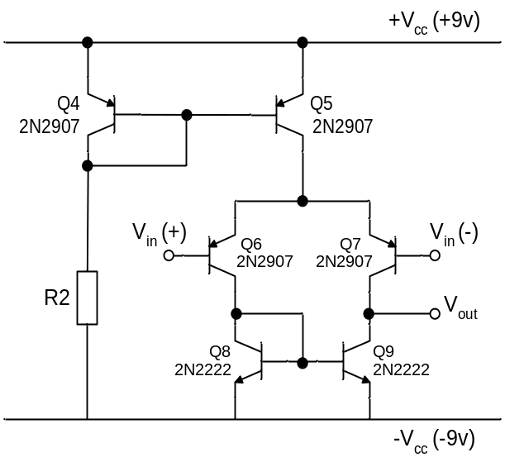

Fig. 2.2 – The differential input stage.

With these amendments the voltage gain of the basic circuit is doubled to become:-

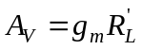

With reference to the circuit in figure 2.2, determine a value for R2 so that the input impedance specification is met.

Calculate the value of R_{L}’ for your circuit assuming that no load is applied to V_{out}.

Hence calculate the theoretical voltage gain of the input stage with no load attached.

Now simulate your circuit and measure its differential voltage gain and differential input impedance.

[Hint – apply the differential input voltage by connecting two small (e.g. 1μV) ac voltage sources between the inputs and ground. These voltage sources should be of equal amplitude, but opposite polarity, so set the sign of each accordingly. Measure the ac input current to determine the input resistance and also the output voltage to determine the voltage gain.]

Answer questions 1, 2 and 3 now

2.2. The complete circuit

You should now combine the differential input designed in this part of the assignment with the voltage amplifier designed in Part 1 to produce an operational amplifier that meets the required specification.

[Hint - you will need to give some consideration to the loading effects on each stage when coupling them together (you should use another emitter follower circuit as an impedance buffer between the two parts of the circuit). Note also that your circuit will now be approaching the limiting size that the student version of PSPICE will allow, so it may be necessary to reduce the transistor count by combining the two pnp current mirror circuits that supply the long tailed pair and the voltage amplifier into one dual current source in the manner shown in fig. 2.3 (a Widlar current source circuit). Choose R2 to meet the collector current requirement of the common emitter stage via Q3 as before and choose R3 to meet the lower current requirement of the differential input stage via Q5. Take care not to exceed the total supply current limit for your complete circuit - see the specification.]

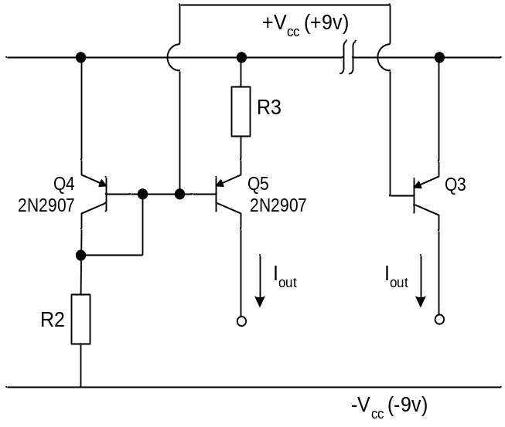

Fig. 2.3 – A dual current mirror circuit.
Now evaluate your op-amp design.

- DC conditions

Enter the complete circuit into Pspice.

To evaluate your design, it is useful to start by obtaining the transfer characteristic (output voltage as a function of input voltage) of your complete amplifier. Obtain this by grounding one input and applying a DC voltage source to the other. Perform a dc sweep from -9V to +9V on this source. The output voltage of your amplifier should change abruptly from one supply voltage limit to the other at some value of input voltage close to zero. The region of change-over is the useful operating range of the amplifier. Outside this range, the amplifier is ‘saturated’ and is unable to amplify the signal input voltage because the output is driven hard against one or other of the supply voltages (approx +/-9V).

Identify the useful operating range and then repeat the plot using a much smaller input voltage range to ‘zoom in’ on the working range of input voltages. The open loop gain can be found from close inspection of the amplifier response over the useful range.

From the transfer characteristic you should also be able to determine the input voltage offset V_{OS} that would need to be applied to the non-inverting input to bring the output close to zero volts (to within, say, 0.1 volts).

Answer question 4 and 5 now

Using appropriate simulations, confirm that all the specifications are met by your design.

Answer question 6 now

- AC conditions

Apply an ac differential input voltage to the inputs - by connecting two small (e.g. 1μV) ac voltage sources between the inputs and ground as you did previously to test the input stage.

You should now run an ac simulation to investigate the frequency response of the amplifier.

Run an ac sweep to measure the voltage gain and phase shift of the output voltage (relative to the input signal voltage) as a function of frequency. Plot both amplitude and phase Bode plots for your amplifier.

Determine the upper cut off frequency (-3dB point) of the voltage gain.

Now investigate the effect on the amplifier voltage gain and phase shift of adding a ‘phase compensating capacitor’ (say 30pF) between the collector of the common emitter stage and the base of the first emitter follower (the impedance buffer). Take care to connect this capacitor in the correct place.

Illustrate the effect of adding the capacitor by plotting the revised Bode plots.

Answer questions 7 & 8 now

(Hint: an op- amp is rarely used just on its own (‘open loop’). Normally negative feedback is applied in which a proportion of the output voltage is taken back and subtracted from the input voltage. It is the difference that is then applied to the op-amp input. However, if at some frequency, phase shifts of 180º occur in the amplifier and feedback circuit combined, then what was intended to be negative feedback will become positive feedback. If this happens, the feedback voltage is effectively added to the input instead of being subtracted. This means that the input signal will be reinforced or even completely replaced by the feedback signal and as a result the amplifier can become unstable and oscillate.

The feedback circuit is often simply a combination of resistors that take a proportion , β, of the output and feed it back to the input. In this case the only phase shift should occur in the op-amp. Is there any frequency at which the phase shift in your op-amp becomes 180º? If so, and the loop gain βA_{OL} is also greater than 1 at that frequency, then the amplifier will become unstable and oscillate when feedback is applied.)

REPORT

The report for this experiment consists only of your answers to the questions 1 – 8 below.

Insert your answers to the questions into the Question Form on page 6 and submit your completed form via ICE (see ICE page for the time of submission deadline)

You should not include the lab script with your submission.

Don’t forget to include your name and student ID number in the space provided

Amplifier properties sheet

Common Emitter
R_{i} = r_{π}

R_{o} = R_{C} //r_{O} ≈ R_{C}

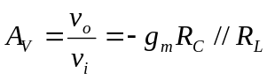

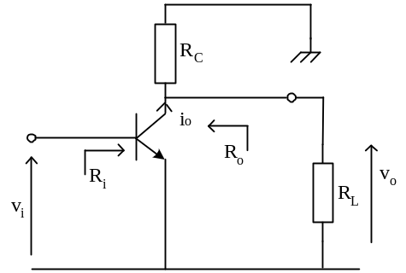
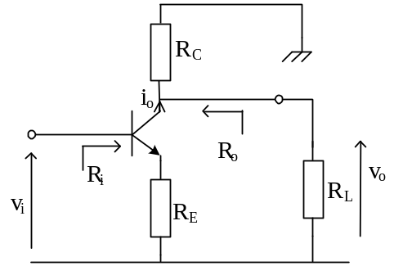Common emitter with emitter degradation
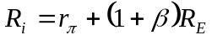

R_{o} = R_{C} //r_{O} ≈ R_{C}

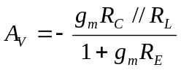

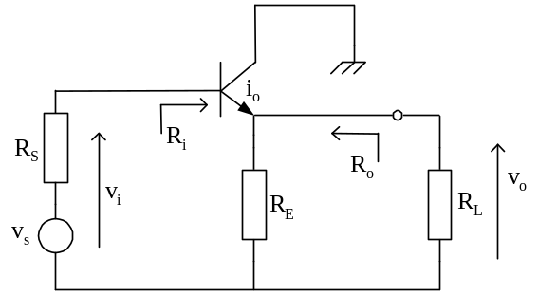Common collector (Emitter follower)
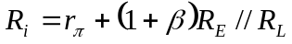

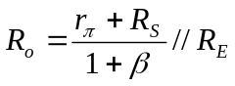

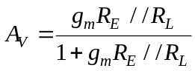

Common base
v
i
R
i
R
C
R
o
R
L
v
o
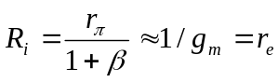

R_{o} = R_{C}

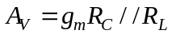

EEE211

PSpice experiment – Part 2
Design of an Operational Amplifier

QUESTION FORM

NAME: STUDENT ID:

…………………………………… ……………………………………

Questions

- Briefly explain how an ‘active load’ doubles the gain of the differential input stage (10%)

- Give the circuit diagram of your differential amplifier input circuit and show your calculation of the differential input resistance and voltage gain of the input stage. (15%)

- Give your measurements used to obtain the input resistance and voltage gain of the input stage by simulation of the circuit. (10%)

- Show the voltage transfer characteristic obtained by simulation . (10%)

- Give your calculation of the open-loop differential voltage gain and the output resistance of the whole amplifier. You should make reference to the amplifier properties sheet included in the laboratory script and make reasonable approximations. (20%)

- Complete the table below.

Specification | Open loop voltage gain | Input resistance (MΩ) | Output resistance (kΩ) | Current from supply  (mA) | Input offset voltage V_{OS}  (mV)
Specified value | > 5 x10⁵ | > 0.1MΩ | < 1kΩ | < 5mA | ---------
Measured value
Calculated value |  |  |  |  | ---------

Compare your measured and calculated values given in the table and account for any significant discrepancies. (10%)

- Give your measured Bode plots
(a) log₁₀ gain magnitude vs log₁₀ frequency, and
(b) linear phase vs log₁₀ frequency
for the op-amp. What can you deduce about the stability of your amplifier from the Bode plots when it is used in a negative feedback circuit? (15%)

- Give your results for the Bode plots obtained with the ‘phase compensating capacitor’, C_{C}, added. With reference to these results, comment on how the addition of C_{C} affects the stability of the op-amp discussed in Question 7.(10%)

EEE211 LAB DOCUMENTS ARE PROVIED BY UoL COPYRIGHT REVERSED.
Tom Dowrick/S Hall/K Nuttall

